AML LAB

Name-Anmol Batch-20 AIML Sap-590011794
Submitted to-Prof. Sahinur Laskar

Index

1 | Data Processing using Python Lib
2 | Predicting House Prices using linear Regression
3 | Predicting Stock Prices using linear Regression
4 | Customer Churn Prediction using Linear regression

1)Data processing using Python libararies

Using pandas to plot and clean data
Using matplotlib and seaborn to plt the outputs

1.Team Name Normalization

1 Some team names appear in different textual formats (e.g., case differences or extra spaces). Clean the team1 and team2 columns by:
  - Converting text to lowercase
  - Removing leading/trailing spaces
  - Verifying unique team names after cleaning
import pandas as pd
import matplotlib.pyplot as plt import seaborn as sns

df=pd.read_csv('/content/drive/MyDrive/data.csv') print(df)

0 | id 1 | season 2008 | city Bangalore | date 2008-04-18 | team1 Kolkata Knight Riders | \
1 | 2 | 2008 | Chandigarh | 2008-04-19 | Chennai Super Kings
2 | 3 | 2008 | Delhi | 2008-04-19 | Rajasthan Royals
3 | 4 | 2008 | Mumbai | 2008-04-20 | Mumbai Indians
4 | 5 | 2008 | Kolkata | 2008-04-20 | Deccan Chargers
.. | ... | ... | ... | ... | ...
572 | 573 | 2016 | Raipur | 2016-05-22 | Delhi Daredevils
573 | 574 | 2016 | Bangalore | 2016-05-24 | Gujarat Lions
574 | 575 | 2016 | Delhi | 2016-05-25 | Sunrisers Hyderabad
575 | 576 | 2016 | Delhi | 2016-05-27 | Gujarat Lions
576 | 577 | 2016 | Bangalore | 2016-05-29 | Sunrisers Hyderabad

 | team2 | toss_winner | toss_decision | \
0 | Royal Challengers Bangalore | Royal Challengers Bangalore | field
1 | Kings XI Punjab | Chennai Super Kings | bat
2 | Delhi Daredevils | Rajasthan Royals | bat
3 | Royal Challengers Bangalore | Mumbai Indians | bat
4 | Kolkata Knight Riders | Deccan Chargers | bat
..  572 | ...  Royal Challengers Bangalore | ...  Royal Challengers Bangalore | ...  field
573 | Royal Challengers Bangalore | Royal Challengers Bangalore | field
574 | Kolkata Knight Riders | Kolkata Knight Riders | field
575 | Sunrisers Hyderabad | Sunrisers Hyderabad | field
576 | Royal Challengers Bangalore | Sunrisers Hyderabad | bat

 | result | dl_applied |  | winner |  | win_by_runs | \
0 | normal | 0 |  | Kolkata Knight Riders |  | 140
1 | normal | 0 |  | Chennai Super Kings |  | 33
2 | normal | 0 |  | Delhi Daredevils |  | 0
3 | normal | 0 |  | Royal Challengers Bangalore |  | 0
4  .. | normal  ... | 0  ... |  | Kolkata Knight Riders  ... |  | 0  ...
572 | normal | 0 |  | Royal Challengers Bangalore |  | 0
573 | normal | 0 |  | Royal Challengers Bangalore |  | 0
574 | normal | 0 |  | Sunrisers Hyderabad |  | 22
575 | normal | 0 |  | Sunrisers Hyderabad |  | 0
576 | normal | 0 |  | Sunrisers Hyderabad |  | 8
0 | win_by_wickets  0 |  | player_of_match BB McCullum |  | \
1 | 0 |  | MEK Hussey
2 | 9 |  | MF Maharoof
3 | 5 |  | MV Boucher
4  .. | 5  ... |  | DJ Hussey  ...
572 | 6 |  | V Kohli
573 | 4 |  | AB de Villiers
574 | 0 |  | MC Henriques
575 | 4 |  | DA Warner
576 | 0 |  | BCJ Cutting

venue umpire1 \
    - M Chinnaswamy Stadium Asad Rauf
    - Punjab Cricket Association Stadium, Mohali MR Benson
    - Feroz Shah Kotla Aleem Dar
    - Wankhede Stadium SJ Davis
    - Eden Gardens BF Bowden
df.shape

(577, 18)
print(df['team1'], df['team2'])

- Kolkata Knight Riders
- Chennai Super Kings
- Rajasthan Royals
- Mumbai Indians
- Deccan Chargers
...
- Delhi Daredevils
- Gujarat Lions
- Sunrisers Hyderabad
- Gujarat Lions
- Sunrisers Hyderabad
Name: team1, Length: 577, dtype: object 0
Royal Challengers Bangalore
- Kings XI Punjab
- Delhi Daredevils
- Royal Challengers Bangalore
- Kolkata Knight Riders
...
- Royal Challengers Bangalore
- Royal Challengers Bangalore
- Kolkata Knight Riders
- Sunrisers Hyderabad
- Royal Challengers Bangalore
Name: team2, Length: 577, dtype: object
df['team1']=df['team1'].str.lower().str.strip() #.str.lower() to convert into lower case and space is removed
df['team2']=df['team2'].str.lower().str.lower() print(df['team1'], df['team2'])
- kolkata knight riders
- chennai super kings
- rajasthan royals
- mumbai indians
- deccan chargers
...
- delhi daredevils
- gujarat lions
- sunrisers hyderabad
- gujarat lions
- sunrisers hyderabad
Name: team1, Length: 577, dtype: object 0
royal challengers bangalore
- kings xi punjab
- delhi daredevils
- royal challengers bangalore
- kolkata knight riders
...
- royal challengers bangalore
- royal challengers bangalore
- kolkata knight riders
- sunrisers hyderabad
- royal challengers bangalore
Name: team2, Length: 577, dtype: object
print(df['team1'].unique())
print(df['team2'].unique())

['kolkata knight riders' 'chennai super kings' 'rajasthan royals' 'mumbai indians' 'deccan chargers' 'kings xi punjab'
'royal challengers bangalore' 'delhi daredevils' 'kochi tuskers kerala' 'pune warriors' 'sunrisers hyderabad' 'rising pune supergiants'
'gujarat lions']
['royal challengers bangalore' 'kings xi punjab' 'delhi daredevils' 'kolkata knight riders' 'rajasthan royals' 'mumbai indians'
'chennai super kings' 'deccan chargers' 'pune warriors'
'kochi tuskers kerala' 'sunrisers hyderabad' 'rising pune supergiants' 'gujarat lions']

2.City Name Standardization

Standardize the city column by:
  - Replacing missing city names with "Unknown" 2)Converting all city names to title case
3)Counting matches played in each city
print(df['city'].isnull().sum())

7
df['city'].fillna('Unknown', inplace=True)

/tmp/ipython-input-357195196.py:1: FutureWarning: A value is trying to be set on a copy of a DataFrame or Series through ch The behavior will change in pandas 3.0. This inplace method will never work because the intermediate object on which we are

For example, when doing 'df[col].method(value, inplace=True)', try using 'df.method({col: value}, inplace=True)' or df[col]

df['city'].fillna('Unknown', inplace=True)
df['city'] = df['city'].str.title() print(df['city'])

- Bangalore
- Chandigarh
- Delhi
- Mumbai
- Kolkata
...
- Raipur
- Bangalore
- Delhi
- Delhi
- Bangalore
Name: city, Length: 577, dtype: object

city  Mumbai | 77
Bangalore | 58
Kolkata | 54
Delhi | 53
Chennai | 48
Chandigarh | 42
Hyderabad | 41
Jaipur | 33
Pune | 25
Durban | 15
Centurion | 12
Ahmedabad | 12
Visakhapatnam | 11
Dharamsala | 9
Johannesburg | 8
Unknown | 7
Abu Dhabi | 7
Cape Town | 7
Port Elizabeth | 7
Ranchi | 7
Cuttack | 7
Raipur | 6
Sharjah | 6
Rajkot | 5
Kochi | 5
Kimberley | 3
East London | 3
Nagpur | 3
Bloemfontein | 2
Indore | 2
Kanpur | 2

3. Toss Decision Text Analysis
cmc=df['city'].value_counts()
print(cmc)
Name: count, dtype: int64

Analyze the toss_decision column:
  - Extract unique decisions
  - Count how many times each decision was taken 3)Visualize the frequency using a bar chart
ud=df['toss_decision'].unique() print(ud)

['field' 'bat']
dc=df['toss_decision'].value_counts()
print("Frequency of each toss decision:") print(dc)

Frequency of each toss decision: toss_decision

team_wins = df_filtered['winner'].value_counts() print(team_wins)
field 315
bat 262
Name: count, dtype: int64
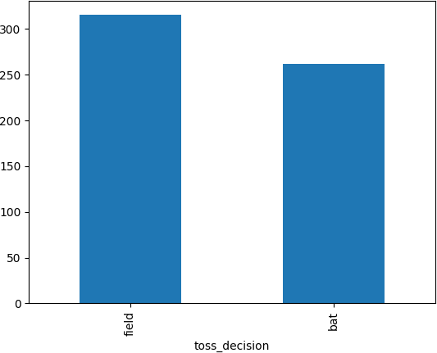
bar=df['toss_decision'].value_counts().plot(kind='bar')

4, Winner Name Extraction

From the winner column:
  - Identify and remove rows where the match result was "No Result" or "Tie"
  - Count how many matches each team won after cleaning text values
df['result'].value_counts()

count
result
normal 568
tie 6
no result 3

dtype: int64
df_filtered = df[~df['result'].isin(['no result', 'tie'])] print(df_filtered)

Original number of matches: 577
Number of matches after removing 'No Result' and 'Tie': 568

winner
Mumbai Indians | 80
Chennai Super Kings | 79
Royal Challengers Bangalore | 69
Kolkata Knight Riders | 68
Rajasthan Royals | 61
Kings XI Punjab | 61
Delhi Daredevils | 56
Sunrisers Hyderabad | 33
Deccan Chargers | 29
Pune Warriors | 12
Gujarat Lions | 9
Kochi Tuskers Kerala | 6
Rising Pune Supergiants  Name: count, dtype: int64 | 5

5. Player of the Match Text Frequency
tp=df['player_of_match'].value_counts().head(10)
print(tp)
Name: count, dtype: int64

Perform text analysis on player of the match:
  - Remove null values
  - Find the top 10 most frequent player names
  - Plot the results using a Seaborn bar plot
pn = df['player_of_match'].dropna() print(pn)

- BB McCullum
- MEK Hussey
- MF Maharoof
- MV Boucher
- DJ Hussey
...
- V Kohli
- AB de Villiers
- MC Henriques
- DA Warner
- BCJ Cutting
Name: player_of_match, Length: 574, dtype: object

player_of_match
CH Gayle | 17
YK Pathan | 16
AB de Villiers | 15
DA Warner | 14
RG Sharma | 13
SK Raina | 13
MEK Hussey | 12
MS Dhoni | 12
G Gambhir | 12
AM Rahane | 12
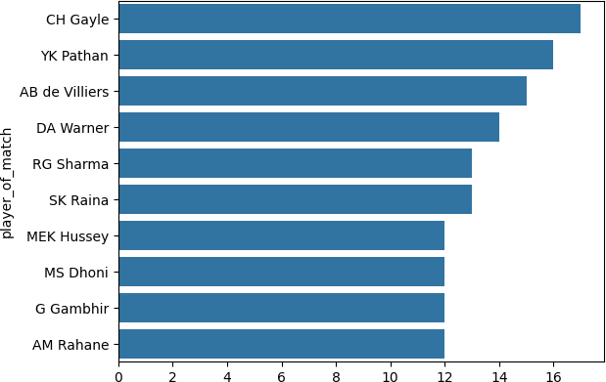
sns.barplot(y=tp.index, x=tp.values)

<Axes: ylabel='player_of_match'>

6. Venue Tokenization

Count how many matches were played in each venue and plot a bar chart for the top10.
venue_counts = df['venue'].value_counts() print(venue_counts.head(10))

venue
M Chinnaswamy Stadium 58
Eden Gardens 54
Feroz Shah Kotla 53

Wankhede Stadium | 49
MA Chidambaram Stadium, Chepauk | 48
Rajiv Gandhi International Stadium, Uppal | 41
Punjab Cricket Association Stadium, Mohali | 35
Sawai Mansingh Stadium | 33
Dr DY Patil Sports Academy | 17
Subrata Roy Sahara Stadium | 17
Name: count, dtype: int64
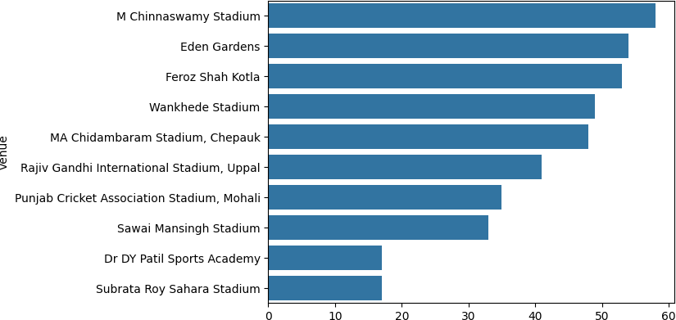
sns.barplot(y=venue_counts.head(10).index, x=venue_counts.head(10).values)

<Axes: ylabel='venue'>

7. Umpire Name Cleaning

Clean umpire columns (umpire1, umpire2, umpire3) by: 1)Replacing missing values with "Not Assigned"
- Removing duplicate umpire names per match
- Finding the most frequently officiating umpire
print(df['umpire1'].isnull().sum())
print(df['umpire2'].isnull().sum())
print(df['umpire3'].isnull().sum())

0
0
0
df['umpire3'].fillna('Not Assigned')
umpire3
- Not Assigned
- Not Assigned
- Not Assigned
- Not Assigned
- Not Assigned
... ...
- Not Assigned
- Not Assigned
- Not Assigned
- Not Assigned
- Not Assigned
- rows × 1 columns

dtype: object

print(df['umpire1'].isnull().sum())
print(df['umpire2'].isnull().sum())
print(df['umpire3'].isnull().sum())

0
0
0
umpire1=df['umpire1'].unique
umpire2=df['umpire2'].unique() umpire3=df['umpire3'].unique()
print(df["umpire1"].head(10))

- Asad Rauf
- MR Benson
- Aleem Dar
- SJ Davis
- BF Bowden
- Aleem Dar
- IL Howell
- DJ Harper
- Asad Rauf
- Aleem Dar
Name: umpire1, dtype: object

8. Create a new text column match_summary by

combining:
team1, team2, winner, and season Example: “MI vs CSK – MI won in 2019” Display sample summaries.
pd.set_option('display.max_colwidth', None)
df['Match_Summary'] = df['team1'] + ' vs ' + df['team2'] + ' - ' + df['winner'].astype(str) + ' won in ' + df['season'].as print(df['Match_Summary'].head())

- kolkata knight riders vs royal challengers bangalore - Kolkata Knight Riders won in 2008
- chennai super kings vs kings xi punjab - Chennai Super Kings won in 2008
- rajasthan royals vs delhi daredevils - Delhi Daredevils won in 2008
- mumbai indians vs royal challengers bangalore - Royal Challengers Bangalore won in 2008
- deccan chargers vs kolkata knight riders - Kolkata Knight Riders won in 2008 Name: Match_Summary, dtype: object

9. Result Type Text Analysis

Analyze the result column:
Identify different textual result types Count their occurrences
Visualize the distribution using a count plot
print(df['result'].unique())

['normal' 'tie' 'no result']
print(df['result'].value_counts())

result
normal 568
tie 6
no result 3
Name: count, dtype: int64
sns.countplot(x=df['result'])

SK Raina | 13
MEK Hussey | 12
MS Dhoni | 12
G Gambhir | 12
AM Rahane | 12
Name: count, | dtype: int64
sns.barplot(y=tp.index, x=tp.values)

<Axes: ylabel='player_of_match'>

6. Venue Tokenization

Count how many matches were played in each venue and plot a bar chart for the top10.
venue_counts = df['venue'].value_counts() print(venue_counts.head(10))

venue  M Chinnaswamy Stadium |  | 58
Eden Gardens |  | 54
Feroz Shah Kotla |  | 53
Wankhede Stadium |  | 49
MA Chidambaram Stadium, Chepauk |  | 48
Rajiv Gandhi International Stadium, | Uppal | 41
Punjab Cricket Association Stadium, | Mohali | 35
Sawai Mansingh Stadium |  | 33
Dr DY Patil Sports Academy |  | 17
Subrata Roy Sahara Stadium  Name: count, dtype: int64 |  | 17

sns.barplot(y=venue_counts.head(10).index, x=venue_counts.head(10).values)

<Axes: ylabel='venue'>

7. Umpire Name Cleaning

Clean umpire columns (umpire1, umpire2, umpire3) by: 1)Replacing missing values with "Not Assigned"
- Removing duplicate umpire names per match
- Finding the most frequently officiating umpire
print(df['umpire1'].isnull().sum())
print(df['umpire2'].isnull().sum())
print(df['umpire3'].isnull().sum())

0
0
0
df['umpire3'].fillna('Not Assigned')

umpire3
- Not Assigned
- Not Assigned
- Not Assigned
- Not Assigned
- Not Assigned
...
...
- Not Assigned
- Not Assigned
- Not Assigned
- Not Assigned
- Not Assigned
- rows × 1 columns

dtype: object
print(df['umpire1'].isnull().sum())
print(df['umpire2'].isnull().sum())
print(df['umpire3'].isnull().sum())

0
0
0
umpire1=df['umpire1'].unique
umpire2=df['umpire2'].unique() umpire3=df['umpire3'].unique()
print(df["umpire1"].head(10))
0
1
2
3
4
5
6
7
8
9
Asad Rauf
MR Benson Aleem Dar SJ Davis BF Bowden Aleem Dar IL Howell DJ Harper Asad Rauf Aleem Dar
Name: umpire1, dtype: object

8. Create a new text column match_summary by

combining:
team1, team2, winner, and season Example: “MI vs CSK – MI won in 2019” Display sample summaries.
pd.set_option('display.max_colwidth', None)
df['Match_Summary'] = df['team1'] + ' vs ' + df['team2'] + ' - ' + df['winne print(df['Match_Summary'].head())
0
1
2
3
4
kolkata knight riders vs royal challengers bangalore - Kolkata Knight Ri
chennai super kings vs kings xi punjab - Chennai Super K rajasthan royals vs delhi daredevils - Delhi Darede
mumbai indians vs royal challengers bangalore - Royal Challengers Banga
deccan chargers vs kolkata knight riders - Kolkata Knight Ri
Name: Match_Summary, dtype: object

9. Result Type Text Analysis

Analyze the result column:
Identify different textual result types Count their occurrences
Visualize the distribution using a count plot
print(df['result'].unique())

['normal' 'tie' 'no result']
print(df['result'].value_counts())
result
normal tie
no result
568
6
3
Name: count, dtype: int64
sns.countplot(x=df['result'])

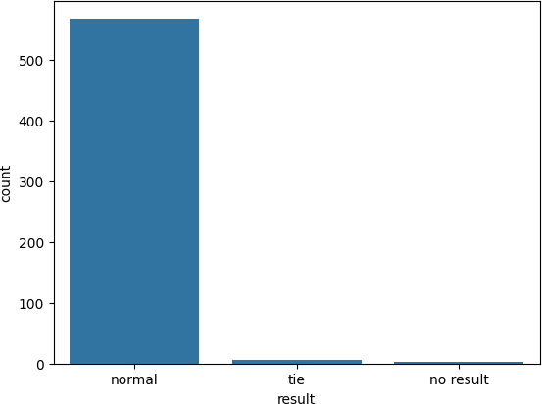
<Axes: xlabel='result', ylabel='count'>
10. Toss Winner vs Match Winner (Text Matching)
Compare text values in toss_winner and winner:
Create a boolean column indicating whether the toss winner also won the match

Visualize the comparison using a bar chart
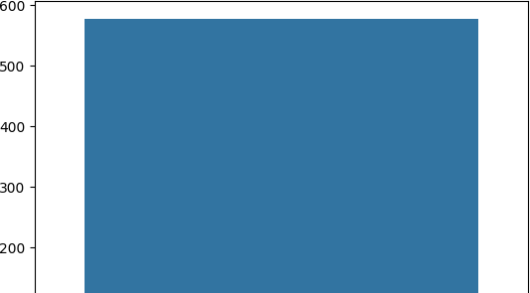
df['toss_decision']=df['toss_winner'].str.strip().str.lower() df['winner']=df['winner'].str.strip().str.lower()
df['toss_won']=df['toss_winner']==df['winner'] print(df['toss_won'].value_counts())

toss_won
False 577
Name: count, dtype: int64
sns.barplot(x=df['toss_won'].value_counts().index, y=df['toss_won'].value_cou

<Axes: xlabel='toss_won'>

